**PROJECT NAME**

HealthCare Analytics

Project Owner: Sairah Susan Prasad

Course: INFO8076 - Fall 2023 - Section 6

**INTRODUCTION**

In this project I have used data from a hospital in order to improve patient care. The project enables healthcare providers to efficiently manage patient data, track admissions, and medications. This can result in improved patient care and outcomes . Let’s name the hospital as **Healthplus Hospitals.** Let’s take a look at a case study detailing my process and output.

**DATASET**

I began by taking a look at the database. The database **hospital_db**has 5 tables. Below are the different tables and a brief description of them.

* **Patient_d -** Contains data such as patient_d Patient_ID , First_Name , Last_Name ,Gender,Contact_Number .
* **Doctor_d -** contains data including Doctor_ID, First_Name, Last_Name, Specialization, Contact_Number, Email.
* **Medications_d –** contains Medication_ID, Medication_Name, Dosage, Route, Frequency, Manufacturer.
* **Admissions_d –** contains Admission_ID, Patient_ID, Doctor_ID, Admission_Date, Discharge_Date, Ward_Type.
* **Patient Medication_f –** contains Admission_ID, Medication_ID, Start_date, End_date, Quantity, Instructions.

**I have analysed the above data using PostgreSQL**

**OBJECTIVES AND GOALS**

In this project, I’ll aim to answer the following questions:

1. **How many males and females visited the hospital?**
2. **What is the total quantity used for each medication?**
3. **How many ward types are available?**
4. **Which are the doctors assigned to each patient?**
5. **Which doctor has the most and least patients?**
6. **Which doctor is responsible for the care of most patients?**
7. **What are the most common routes of medication administration?**
8. **What is the total revenue generated from patient admissions?**
9. **Which medical specialization has the highest number of doctors?**
10. **What medications are typically prescribed to patients during their hospital stay?**
11. **Show the list of all Patient Admissions.**
12. **View all the Doctors and Their Specializations list**.
13. **Show all the medication and their instructions.**

Before getting started with analyses, I first tried understanding the ERM (Entity Relationship Model) of this database also known as Schema. Here is the Schema below:

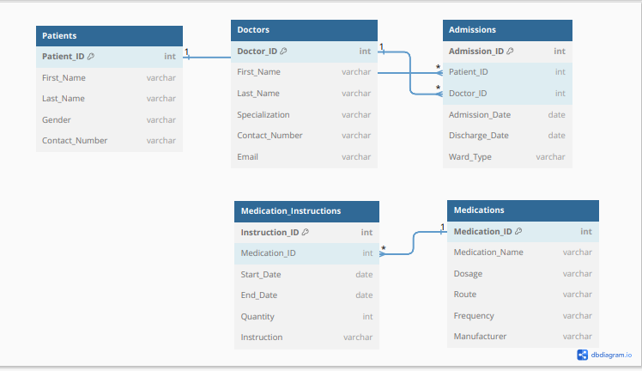

#### Analysis

1. To answer the first question**“How many males and females visited the hospital?”**

Below is the query I used to extract to answer the question:

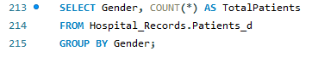

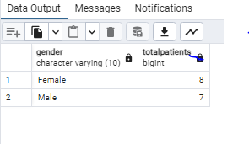

**INSIGHTS**

This information provides insights into the patient demographics based on gender, showing that there are 7 male patients and 8 female patients in the hospital records.

1. **What is the total quantity used for each medication?**

Below is the query I used to extract to answer the question:

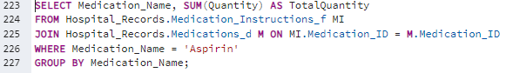

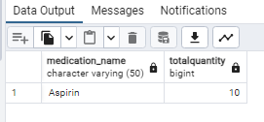

This means that the total quantity of 'Aspirin' prescribed is 10 units based on the data in the tables.

1. **How many ward types are available?**



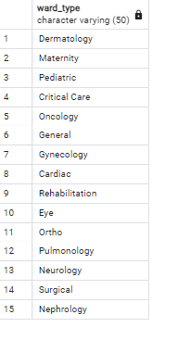

This list represents all the different ward types present in the admissions data without any repetitions.

1. **Which are the doctors assigned to each patient?**



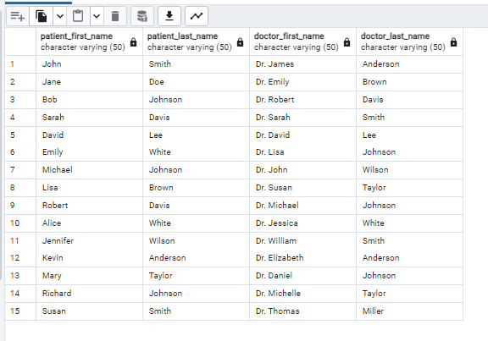

The result of this query provides insights into patient-doctor relationships during admissions. It returns a list of patients along with the doctors who attended to them during their admissions. If a patient had multiple admissions or different doctors during admissions, you would see multiple rows with the corresponding patient and doctor names.

**5.Which doctor has the most and least patients?**

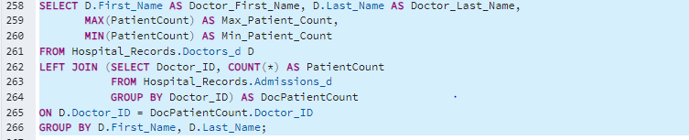

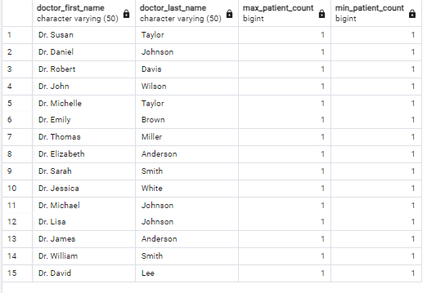

The result of this query provides insights into doctors' patient loads, showing the doctor with the maximum and minimum patient counts. This information can be valuable for assessing the workload of healthcare professionals in the hospital.

**6.Which doctor is responsible for the care of most patients?**

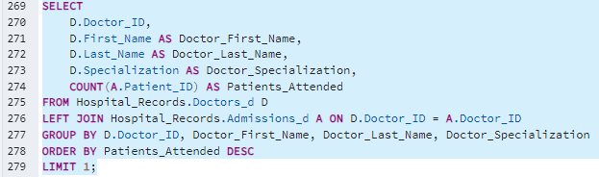

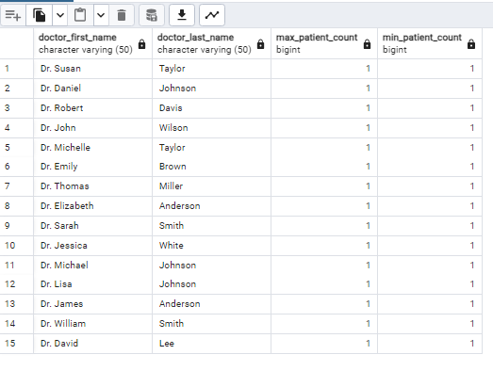

The result of this query provides insight into which doctor has the highest patient workload. This information is valuable for understanding the distribution of patient care responsibilities among the medical staff in the hospital.

7. **What are the most common routes of medication administration?**

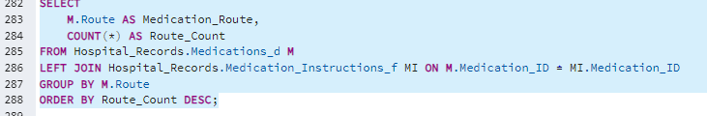

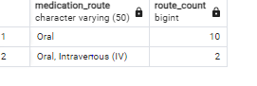

The result of this query provides insights into which routes of medication administration are the most common in the hospital. This information is valuable for understanding how medications are typically administered to patients, which can be important for medical staff and inventory management.

8. **Which medical specialization has the highest number of doctors?**

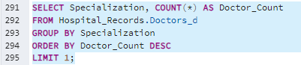

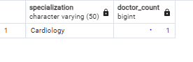

The result of this query provides insights into which medical specialization has the most doctors in the hospital. This information is valuable for understanding the distribution of medical expertise within the facility and can inform decisions related to staffing and patient care.

**9. What medications are typically prescribed to patients during their hospital stay?**



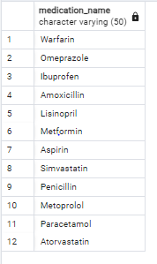

The results are ordered in descending order of the prescription count, showing the most frequently prescribed medications at the top.

These insights help identify which medications are commonly prescribed to patients during their hospital stay. This information can be valuable for managing medication inventory, assessing patient needs, and improving overall healthcare services.

**10. Show all the Patient Admissions**

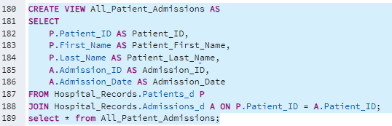

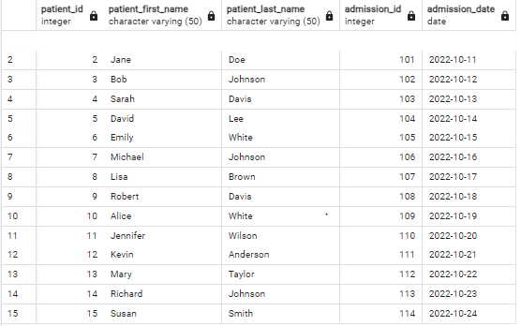

This table shows the list of all the patients admitted in the hospital along with the admission id and the admission date.

**11.View all the Doctors and Their Specializations list**.

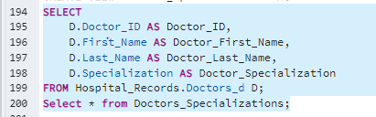

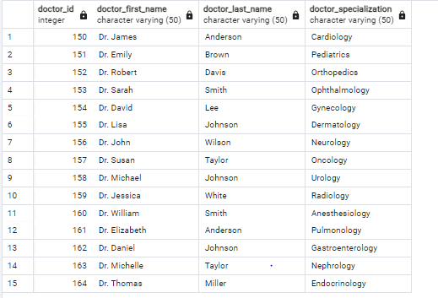

The above query is used to view the doctors and their specialization available in the hospital.

**12**. **Show all the Medications and Their Instructions.**

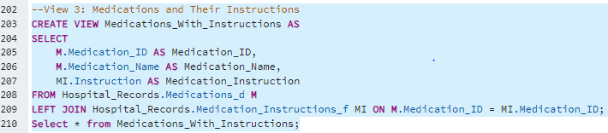

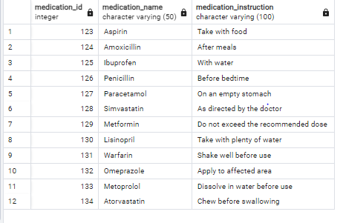

**PROJECT DELIVERABLES**

* The project includes a well-structured database schema doc made with the help of  [Untitled - dbdiagram.io](https://dbdiagram.io/d/6533fca8ffbf5169f02b2170) this includes a DB.SQL file and DB.PDF file which covers the schema and key relations.
* Comprehensive documentation and an Excel sheet for data reference.
* All queries run fine on PosgresSQL PGadmin4 and have been verified.

**SUMMARY**

In this project ,I have used the data from a hospital and analysed the data to answer different questions .There are 13 queries I have used in this project .Different sql functions are used in my project such as group by,order by,left join,right join,inner join,count,distinct,view etc.The data types I have used are INT,VARCHAR,DATES etc.